Exercise 15
- List all employee ids and birth dates who were born before 1965.
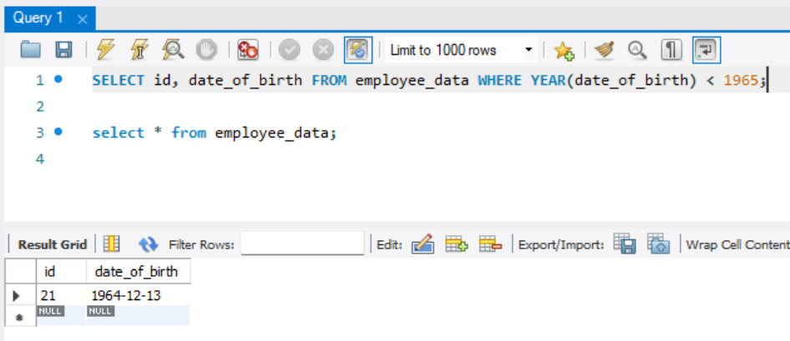
- Display Ids and birth dates of employees born in and between 1970 and 1972(this is tricky.. you need to give it a little thought)
